PRACTICAL FILE

COURSE : ARTIFICIAL INTELLIGENCE
SUBJECT CODE : MC 307
B.TECH SEMESTER-V


DEPARTMENT OF APPLIED MATHEMATICS
DELHI TECHNOLOGICAL UNIVERSITY

(FORMELY DELHI COLLEGE OF ENGINEERING)
BAWANA ROAD , DELHI – 110042

SUBMITED BY : LOKESH GODARA
ROLL NO . : 23/MC/082
SUBMITED TO : Ms. REETIKA SINGH
Ms. DRISHTI

INDEX

S.No. | Experiments | Date | Remarks
1. | Write a program to solve the 8-Puzzle problem using Generate and Test Strategy.
2. | Write a program to solve the 8-Puzzle problem using DFID Technique.
3. | Write a program to solve the 3-SAT Problem using Variable Neighbourhood Descent Algorithm.
4. | Write a program to solve the 3- SAT Problem using Stochastic Hill Climbing Algorithm.
5. | Write a program to solve the 8-Puzzle problem using A* algorithm.
6. | Write a program to solve AND OR Graph using AO* Search Algorithm.
7. | WAP to find maximum of two/three numbers.
8. | WAP to find factorial of a number.
9. | WAP to find sum of first N numbers.
10. | Write a program to find Fibonacci sequence upto Nth term.
11 | Write a program to implement decision tree and naive bayes algorithm and produce the training and testing performance in the form of accuracy and F-score on the IRIS.csv dataset

Experiment 1
Aim: Write a program to solve the 8-Puzzle problem using Generate and Test Strategy.

Code:

#include<bits/stdc++.h>
using namespace std;

int solve8Puzzle(vector<vector<int>> &grid){
vector<vector<int>> dir={{1,3},{0,2,4},{1,5},{0,4,6},{1,3,5,7},{2,4,8},{3,7},{4,6,8},{5,7}}; string start="", goal="123804765";
int zeroPos;

for(int i=0;i<3;i++){ for(int j=0;j<3;j++){ start+=to_string(grid[i][j]);
if(grid[i][j]==0) zeroPos=3*i+j;
}
}

queue<pair<string,int>> q; unordered_set<string> visited; q.emplace(start,zeroPos); visited.insert(start);
int moves=0, sz;

while(!q.empty()){ sz=q.size(); while(sz--){ auto ele=q.front(); q.pop(); string state=ele.first; int pos=ele.second; if(state==goal) return moves; for(int next:dir[pos]){ swap(state[pos],state[next]); if(!visited.count(state)){ visited.insert(state);
q.emplace(state,next);
}
swap(state[pos],state[next]);
}
}
moves++;
}
return -1;
}

int main(){
vector<vector<int>> grid(3,vector<int>(3)); cout<<"Enter the initial 3x3 grid (use 0 for blank):\n"; for(int i=0;i<3;i++)
for(int j=0;j<3;j++) cin>>grid[i][j];

int result=solve8Puzzle(grid);
if(result!=-1) cout<<"Solved in "<<result<<" moves.\n"; else cout<<"Unsolvable puzzle.\n";

return 0;
}

Output:

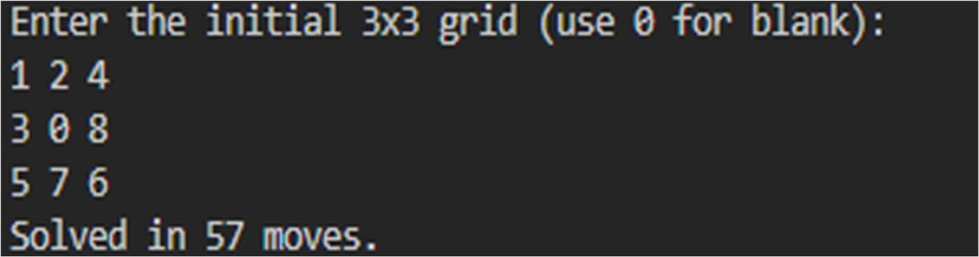

Experiment 2
Aim: Write a program to solve the 8-Puzzle problem using DFID Technique.

Code:

#include<bits/stdc++.h>
using namespace std;

vector<vector<int>> dir={{1,3},{0,2,4},{1,5},{0,4,6},{1,3,5,7},{2,4,8},{3,7},{4,6,8},{5,7}}; string goal="123804765";

bool DLS(string state, int pos, int depth, unordered_set<string> &visited){ if(state==goal) return true;
if(depth==0) return false;

visited.insert(state); for(int next:dir[pos]){ swap(state[pos],state[next]); if(!visited.count(state)){
if(DLS(state, next, depth-1, visited)) return true;
}
swap(state[pos],state[next]);
}
visited.erase(state);
return false;
}

int DFID(vector<vector<int>> &grid){ string start=""; int zeroPos; for(int i=0;i<3;i++) for(int j=0;j<3;j++){ start += to_string(grid[i][j]);
if(grid[i][j]==0) zeroPos = 3*i + j;
}

for(int depth=0; depth<=50; depth++){ unordered_set<string> visited; if(DLS(start, zeroPos, depth, visited)) return depth;
}
return -1;
}

int main(){
vector<vector<int>> grid(3,vector<int>(3)); cout<<"Enter the initial 3x3 grid (use 0 for blank):\n"; for(int i=0;i<3;i++)
for(int j=0;j<3;j++) cin>>grid[i][j];

int result = DFID(grid); if(result != -1) cout<<"Solved in "<<result<<" moves using DFID.\n"; else cout<<"Unsolvable puzzle (or exceeds depth limit).\n";

return 0;
}

Output

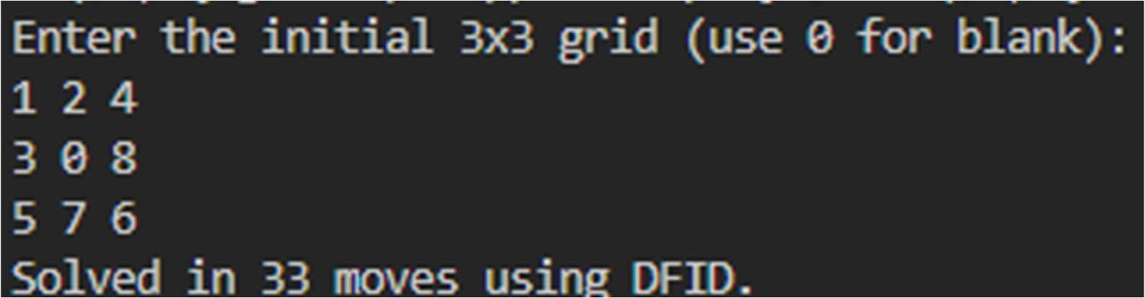

Experiment 3
Aim: Write a program to solve the 3-SAT Problem using Variable Neighbourhood Descent Algorithm.

Code:

#include<bits/stdc++.h>
using namespace std;

using Clause = vector<int>;
using Formula = vector<Clause>;

int evaluate(Formula &formula, vector<bool> &assignment) { int satisfied = 0;
for(const auto &clause : formula){ for(int lit : clause){ int var = abs(lit) - 1; bool val = (lit > 0) ? assignment[var] : !assignment[var]; if(val){ satisfied++; break; }
}
}
return satisfied;
}

bool VND(const Formula &formula, int nVars, vector<bool> &assignment){ int totalClauses = formula.size(); int bestScore = evaluate(formula, assignment);

while(true){ bool improved = false; for(int i=0;i<nVars;i++){ assignment[i] = !assignment[i];
int newScore = evaluate(formula, assignment); if(newScore > bestScore){ bestScore = newScore; improved = true;
break;
} else assignment[i] = !assignment[i];
}
if(!improved) break;
}

return bestScore == totalClauses;
}

int main(){
int nVars=3, nClauses;
cout << "Enter number of clauses: "; cin >> nClauses;

Formula formula(nClauses); cout << "Enter clauses (use negative for negation):\n"; for(int i=0;i<nClauses;i++){ Clause clause(3);
for(int j=0;j<3;j++) cin >> clause[j]; formula[i] = clause;
}

for(int attempt=0;attempt<1000;attempt++){ vector<bool> assignment(nVars);
for(int i=0;i<nVars;i++) assignment[i] = rand()%2;

if(VND(formula, nVars, assignment)){ cout << "Satisfiable assignment found:\n";
for(int i=0;i<nVars;i++) cout << "x" << (i+1) << " = " << assignment[i] << "\n"; return 0;
}
}

cout << "No satisfying assignment found (may be unsatisfiable).\n"; return 0;
}

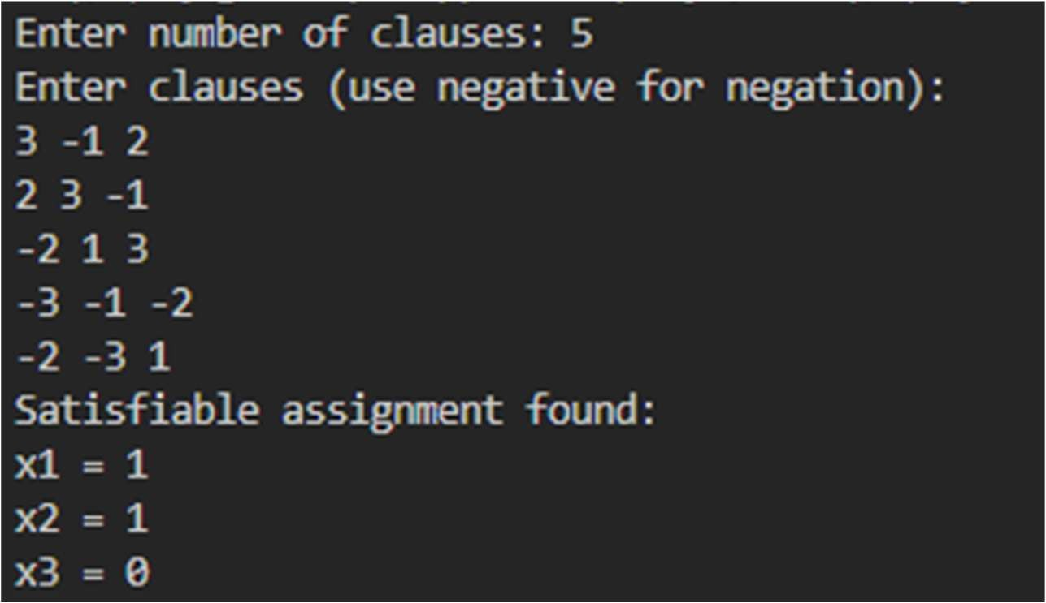
Output:

Experiment-4

Aim: Write a program to solve the 3- SAT Problem using Stochastic Hill Climbing Algorithm.

Code:
#include<bits/stdc++.h>
using namespace std;

using Clause = vector<int>;
using Formula = vector<Clause>;

int evaluate(Formula &formula, vector<bool> &assignment) { int satisfied = 0;
for(const auto &clause : formula){ for(int lit : clause){ int var = abs(lit) - 1;
bool val = (lit > 0) ? assignment[var] : !assignment[var]; if(val){ satisfied++; break; }
}
}
return satisfied;
}

bool stochasticHillClimbing(Formula &formula, int nVars, vector<bool> &assignment, int maxIter = 10000){ int totalClauses = formula.size();
int bestScore = evaluate(formula, assignment);

for(int iter=0;iter<maxIter;iter++){ int var = rand() % nVars;
assignment[var] = !assignment[var];

int newScore = evaluate(formula, assignment); if(newScore >= bestScore){ bestScore = newScore;
if(bestScore == totalClauses) return true;
} else {
assignment[var] = !assignment[var];
}
}

return false;
}

int main(){
srand(time(0));

int nVars, nClauses; cout << "Enter number of variables and clauses: "; cin >> nVars >> nClauses;

Formula formula(nClauses); cout << "Enter clauses (use negative for negation):\n"; for(int i=0;i<nClauses;i++){ Clause clause(3); for(int j=0;j<3;j++) cin >> clause[j]; formula[i] = clause;
}

for(int attempt=0;attempt<100;attempt++){ vector<bool> assignment(nVars);
for(int i=0;i<nVars;i++) assignment[i] = rand() % 2;

if(stochasticHillClimbing(formula, nVars, assignment)){ cout << "Satisfiable assignment found:\n";
for(int i=0;i<nVars;i++)
cout << "x" << (i+1) << " = " << assignment[i] << "\n"; return 0;
}
}

cout << "No satisfying assignment found (may be unsatisfiable).\n"; return 0;
}

Output:

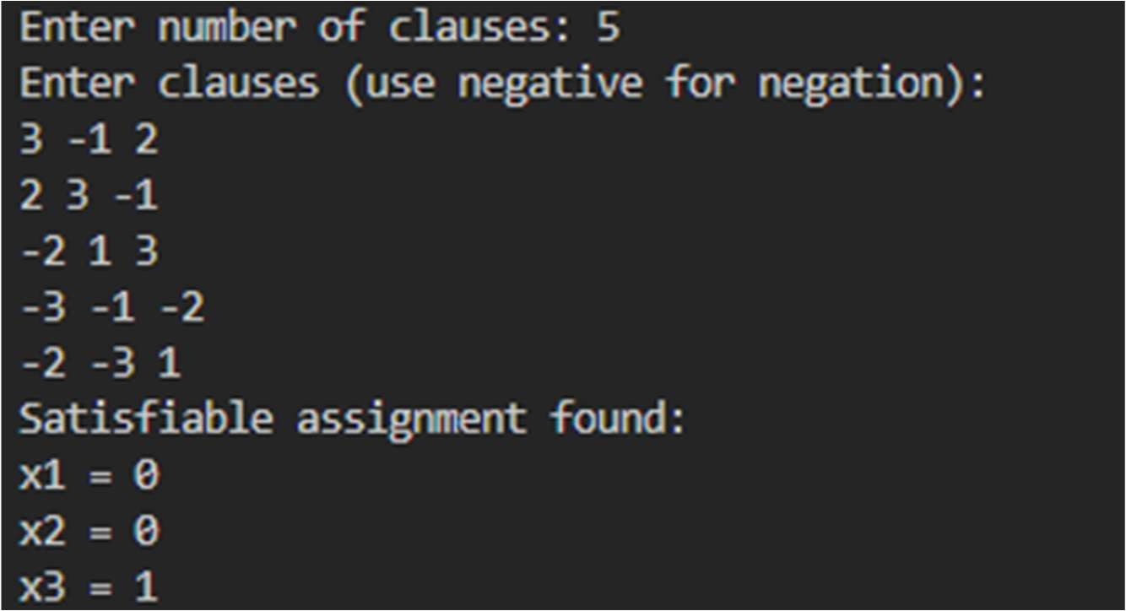

Experiment-5

Aim: Write a program to solve the 8-Puzzle problem using A* algorithm.
Code:
#include<bits/stdc++.h>
using namespace std;

int heuristic(string &state, string &goal){ int cnt=0;
for(int i=0;i<9;i++) cnt+=(state[i]!=goal[i]); return cnt;
}

int solve8PuzzleAStar(vector<vector<int>> &grid){ vector<vector<int>> dir={{1,3},{0,2,4},{1,5},{0,4,6},{1,3,5,7},{2,4,8},{3,7},{4,6,8},{5,7}}; string start="", goal="123804765";
int zeroPos;

for(int i=0;i<3;i++) for(int j=0;j<3;j++){ start+=to_string(grid[i][j]);
if(grid[i][j]==0) zeroPos=3*i+j;
}

using State=tuple<int,int,string,int>; // f, g, state, pos priority_queue<State,vector<State>,greater<State>> pq; unordered_set<string> visited;

int h=heuristic(start,goal); pq.emplace(h,0,start,zeroPos);
visited.insert(start);

while(!pq.empty()){
State S=pq.top(); pq.pop();
int f=get<0>(S), g=get<1>(S), pos=get<3>(S);
string state=get<2>(S); if(state==goal) return g; for(int next:dir[pos]){ swap(state[pos],state[next]); if(!visited.count(state)){ int h=heuristic(state,goal); pq.emplace(g+1+h,g+1,state,next);
visited.insert(state);
}
swap(state[pos],state[next]);
}
}
return -1;
}

int main(){
vector<vector<int>> grid(3,vector<int>(3)); cout<<"Enter the initial 3x3 grid (use 0 for blank):\n"; for(int i=0;i<3;i++)
for(int j=0;j<3;j++) cin>>grid[i][j];

int result=solve8PuzzleAStar(grid);
if(result!=-1) cout<<"Solved in "<<result<<" moves using A*.\n";
else cout<<"Unsolvable puzzle.\n";

return 0;
}

Output:

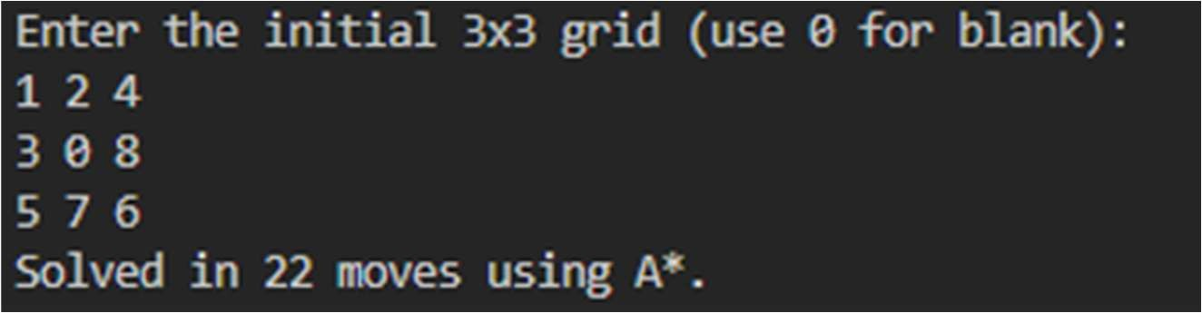

Experiment 6
Aim: Write a program to solve AND OR Graph using AO* Search Algorithm.
Code:
#include <bits/stdc++.h>
using namespace std;

struct Node { string name;
vector<vector<string>> children; vector<int> costs; bool solved = false; int finalCost = INT_MAX;
vector<string> solution;
};

unordered_map<string, Node> graph;

// Function to recursively apply AO* Search pair<vector<string>, int> aoStar(string nodeName) {
Node &node = graph[nodeName];

if (node.solved) return {node.solution, node.finalCost};

// Goal node (no children) if (node.children.empty()) { node.solved = true; node.finalCost = 0; node.solution = {nodeName};
return {node.solution, 0};
}

int minCost = INT_MAX;
vector<string> bestSol;

for (int i = 0; i < node.children.size(); ++i) { int cost = node.costs[i]; vector<string> tempSol = {nodeName};
int subCost = 0;
bool allSolved = true;

for (const string &child : node.children[i]) { auto ele = aoStar(child); vector<string> sol=ele.first; int c=ele.second; if (graph[child].solved) { tempSol.insert(tempSol.end(), sol.begin(), sol.end()); subCost += c;
} else { allSolved = false;
break;
}
}

if (allSolved && cost + subCost < minCost) { minCost = cost + subCost;
bestSol = tempSol;
}
}

node.solved = true; node.finalCost = minCost; node.solution = bestSol;
return {bestSol, minCost};
}

int main() {
graph["g1"] = {"g1", {}, {}, true, 0, {"g1"}}; graph["g2"] = {"g2", {}, {}, true, 0, {"g2"}}; graph["g3"] = {"g3", {}, {}, true, 0, {"g3"}};

graph["b"] = {"b", {{"g1"}}, {1}};
graph["c"] = {"c", {{"g2", "g3"}}, {2}};

graph["a"] = {"a", {{"b"}, {"c"}}, {1, 2}};

auto ele = aoStar("a"); vector<string> solution=ele.first; int cost=ele.second;

cout << "AO* Solution Path: "; for (auto &node : solution) cout << node << " ";
cout << "\nTotal Cost: " << cost << endl;

return 0;
}

Output:

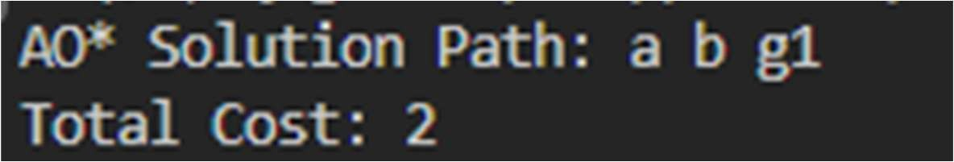

Experiment-7

Aim: WAP to find maximum of two/three numbers. Code:

max2(X, Y, X) :- X >= Y. max2(X, Y, Y) :- X < Y. max3(X, Y, Z, Max) :- max2(X, Y, TempMax), max2(TempMax, Z, Max).
Output:

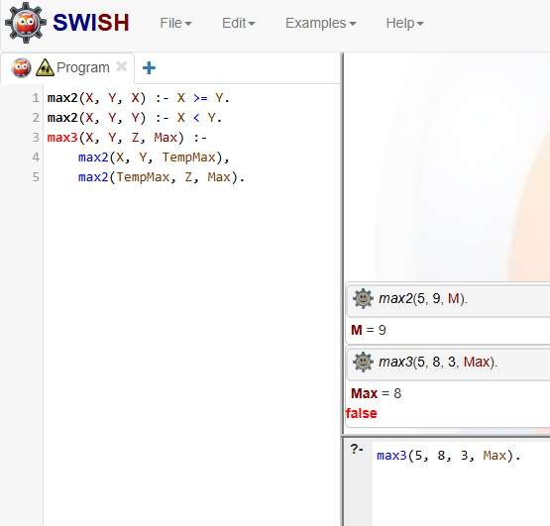

Experiment 8
Aim: WAP to find factorial of a number.

Code:

factorial(0, 1). factorial(N, F) :- N > 0, N1 is N - 1, factorial(N1, F1), F is N * F1.

Output:

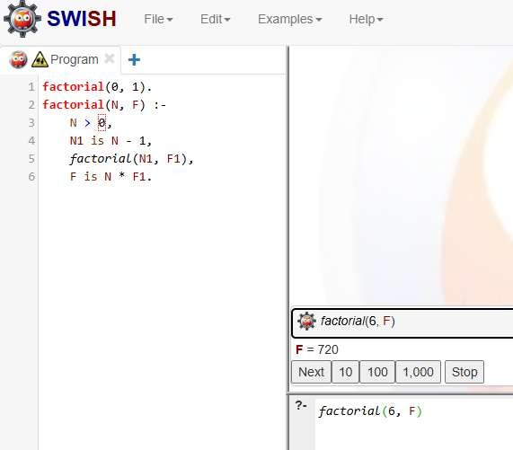

Experiment-9

Aim: WAP to find sum of first N numbers.

Code:
sumFirstn(0, 0).
sumFirstn(N, Sum) :- N > 0,
N1 is N - 1, sumFirstn(N1, S1), Sum is N + S1.
Output:
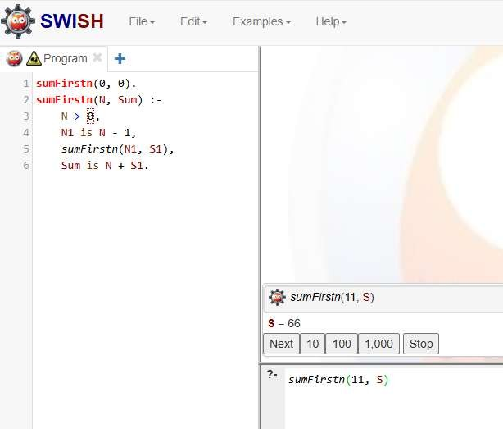

Experiment-10
Aim: Write a program to find Fibonacci sequence upto Nth term.

Code: fibonacci(0, [0]). fibonacci(1, [0, 1]). fibonacci(N, Seq) :- N > 1, fibonacci_helper(2, N, [1, 0], SeqRev), reverse(SeqRev, Seq).

fibonacci_helper(I, N, Acc, Acc) :- I > N. fibonacci_helper(I, N, [A, B | Rest], Seq) :- C is A + B, I1 is I + 1, fibonacci_helper(I1, N, [C, A, B | Rest], Seq).

Output:

